**PROJECT REPORT**



**DATA STRUCTURES**

BSCS-402

**SUBMITTED BY:**

**Muhammad Amas (B20102077)**

**Urooba Shameem (B20102180)**

**SUBMITTED TO:**

**Dr. Muhammad Saeed**

**DEPARTMENT OF COMPUTER SCIENCE**

UNIVERSITY OF KARACHI

**ACKNOWLEGMENT**

The beatitude, bliss & euphoria that accompany the successful completion of any task would be incomplete without the expression of the appreciation of simple virtues to the people who made it possible. So, with reverence veneration, and honor. We acknowledge all those whose guidance and encouragement have made us successful in winding up this. We are thankful to Dr. Muhammad Saeed for his valuable suggestions and enthusiastic interest during the entire session. We perceive this opportunity as a big milestone in my career development. I will strive to use gained skills and knowledge in the best possible way, and I will continue to work on their improvement, in order to attain desired career objectives. Hope to continue cooperation with all of you in the future.

QUIZ GAME:

**INTRODUCTION:**

A quiz is a form of game or mind sport in which players attempt to answer questions correctly about a certain or variety of subjects. Quizzes can be used as a brief assessment in education and similar fields to measure growth in knowledge, abilities, or skills. They can also be televised for entertainment purposes, often in a game show format

**KEY FUNCTIONS OF QUIZ GAME:**

* Can be integrated with the school management system.
* Mark standard data import/export.
* Book data fetching from ISBN site and Google API saves data entry time.
* Fully secured & maintenance-free.
* Fully documented user manual.
* Best Marks management software.
* Backup and recovery provision.
* Reports/Data export to word, excel, PDF, text by analyzing the result in the application.
* No duplication of work.
* No restrictions & no hidden costs.

**MERITS OF QUIZ GAME:**

The following are the major advantages of Quiz Game.

* The Quiz Game is user-friendly, intuitive, and easy-to-use.
* It offers 24*7 access to the Teachers if the interface is enhanced.
* Provides functionalities like acquisition, data recording, cataloguing, marks control, etc.
* Highly secure and efficient database management.
* Provides greater efficiency of work processes & saves time of Quiz giver.
* Cost-effective software for institutes and can be configured as per requirements.

**SOURCE CODE:**

print("\t\tQuiz For python")

print("\tSelect answers in Variables. i.e (a, b, c, or d)\n")

# Asking user's name.

a=input("What is your name?: ")

# Welcoming the user.

print ("\t\tWelcome to the Python Quiz " + a, "!!", "\n")

# Asking user to start the Quiz

x=float(input("Type any number to start the quiz : "))

if x >= 0 :

     # initiating class

     class Question:

          def __init__(self, prompt, answer):

               self.prompt = prompt

               self.answer = answer

     #Qustions for the Quiz in the form of list.

     question_prompts = [

          "1) Python is a ?"

          "\n(a)Machine Language \n(b)Data Language \n(c)Programming Language\n(d)Speaking Language \nAnswer :",

          "2) what we use to shift on next line in Python?"

          "\n(a)(\ n) \n(b) <br>\n(c) next\n(d) new \nAnswer :",

          "3) What symbol we use for exponents in Python?"

          "\n(a) ^ \n(b)& \n(c)@ \n(d)** \nAnswer :",

          "4) Which function is used to provide output to the screen?"

          "\n(a)print() \n(b)output() \n(c)out \n(d)to \nAnswer :",

          "5) What is the correct file extension for Python files?"

          "\n(a).pyth  \n(b).json \n(c).py \n(d).pt \nAnswer :",

          "6) How do you insert Comments in Python code?"

          "\n(a)%  \n(b)# \n(c)!...! \n(d)// \nAnswer :",

          "7) How do you create a variable with the numeric value 5?"

          "\n(a)x=float(5)  \n(b)x=5 \n(c)Both are correct \n(d)Both are incorrect \nAnswer :",

"8) What is the correct way to create a function in Python?"

          "\n(a)def myfunction():  \n(b)create myfunction(): \n(c)function() \n(d)create \nAnswer :",

          "9) Which operator is used to multiply numbers in python?"

          "\n(a)x  \n(b)* \n(c)# \n(d)** \nAnswer :",

          "10) Which operator can be used to compare two values in python?"

          "\n(a)<>  \n(b)= \n(c)>< \n(d)== \nAnswer :",

          "11) How to make a empty list of variable x in python?"

          "\n(a)x=[]   \n(b)x{} \n(c)x=list \n(d)x=() \nAnswer :",

          "12) How do you start writing an if statement in Python?"

          "\n(a)if x>y then:  \n(b)if x>y then \n(c)if (x>y) \n(d)if x>y : \nAnswer :",

          "13) How do you start writing a while loop in Python?"

          "\n(a)while x>y  \n(b)while x>y { \n(c)while (x>y) \n(d)while x>y : \nAnswer :",

          "14) How do you start writing a for loop in Python?"

          "\n(a)for x in y  \n(b)for x in y: \n(c)for x>y \n(d)for x>y: \nAnswer :",

          "15) Which statement is used to stop a loop?"

          "\n(a)stop  \n(b)return \n(c)exit \n(d)break \nAnswer :",

     ]

     #Giving answers in the form of list.

     questions = [

          Question(question_prompts[0], "c"),

          Question(question_prompts[1], "a"),

          Question(question_prompts[2], "d"),

          Question(question_prompts[3], "a"),

          Question(question_prompts[4], "c"),

          Question(question_prompts[5], "b"),

          Question(question_prompts[6], "c"),

          Question(question_prompts[7], "a"),

          Question(question_prompts[8], "b"),

          Question(question_prompts[9], "d"),

          Question(question_prompts[10], "a"),

          Question(question_prompts[11], "d"),

          Question(question_prompts[12], "d"),

          Question(question_prompts[13], "b"),

          Question(question_prompts[14], "d"),

     ]

     #Creating function for printing.

     def run_quiz(questions):

          score = 0

          for question in questions:

               answer = input(question.prompt)

               # checking answers

               if answer == question.answer:

                    # Adding Scores after each question

                    score += 1

               # Printing points after each Question.

               # no matter right or wrong

               print ("point:"), print(score)

          #Pinting score.

          print("you got "+str (score) + "/" + str(len(questions)))

          # printing "you played well :)"

          if (score >= 7):

               print ("\nYou played Well :)")

     #Run command for the whole Program.

     run_quiz(questions)

     # Printing Thank You...

     print ("Thank You for playing <3\n")

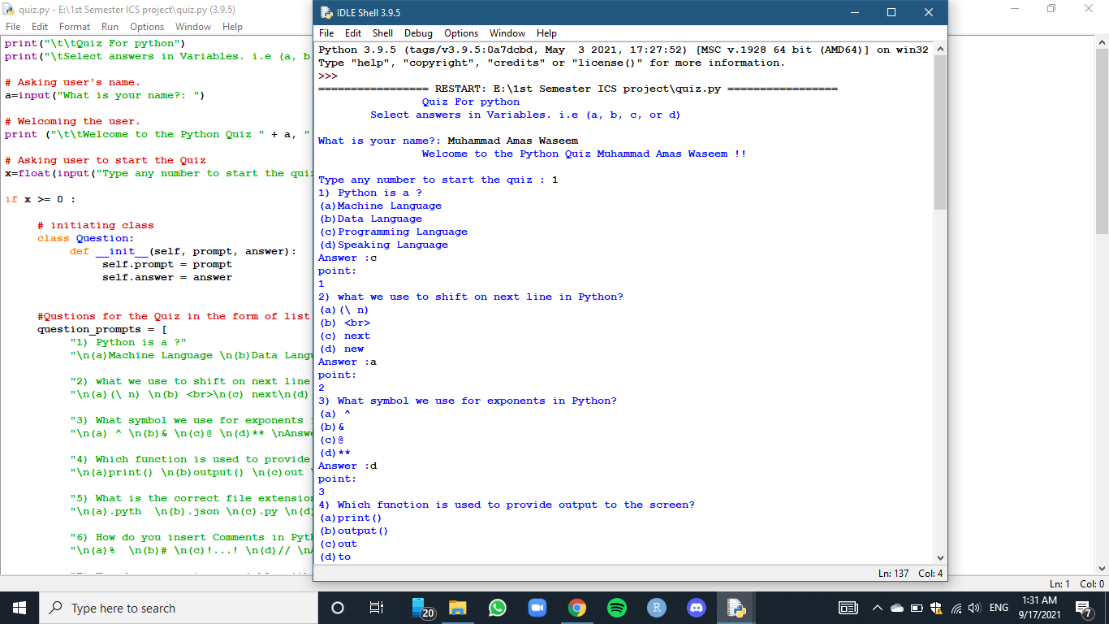**OUTPUT:**

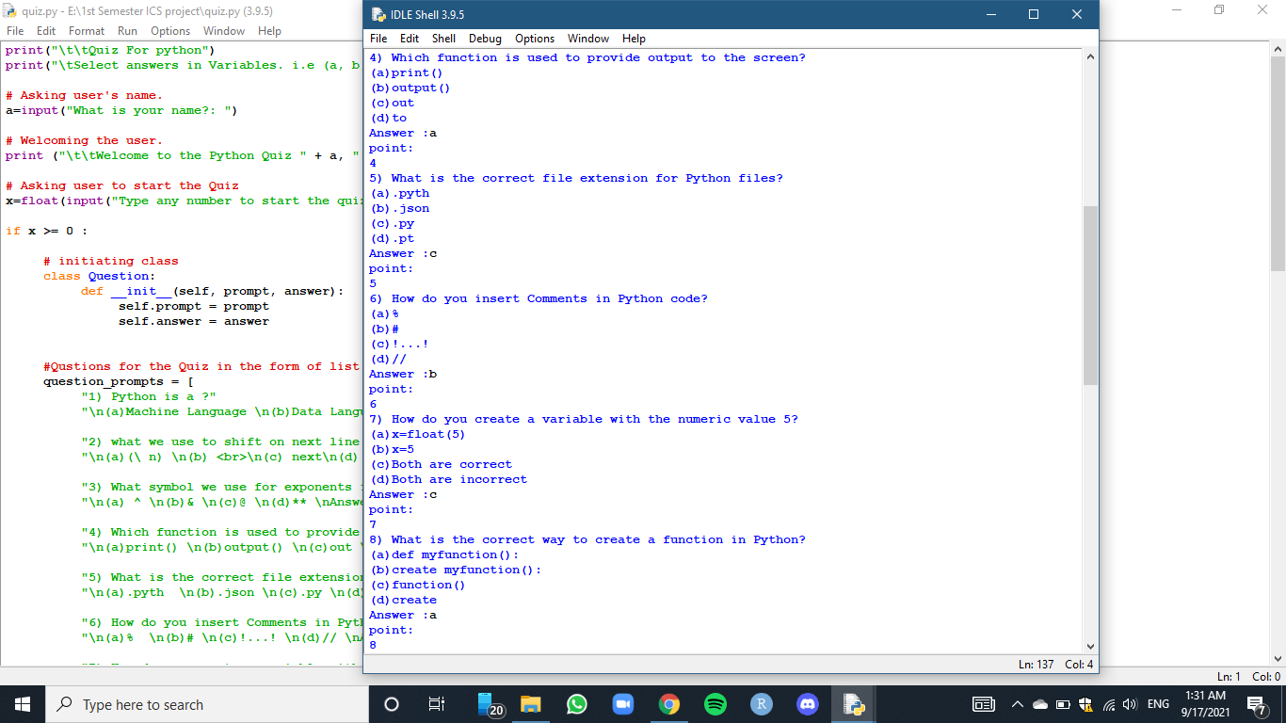  
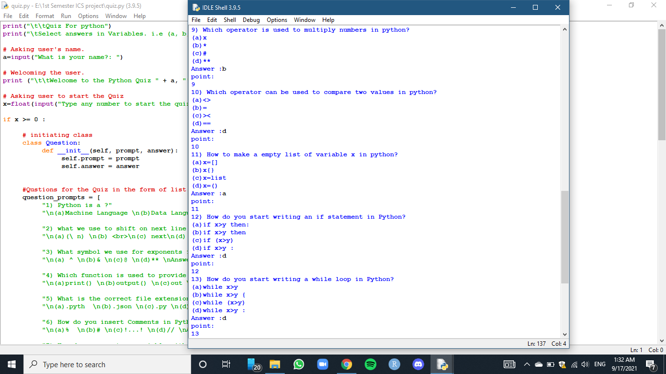

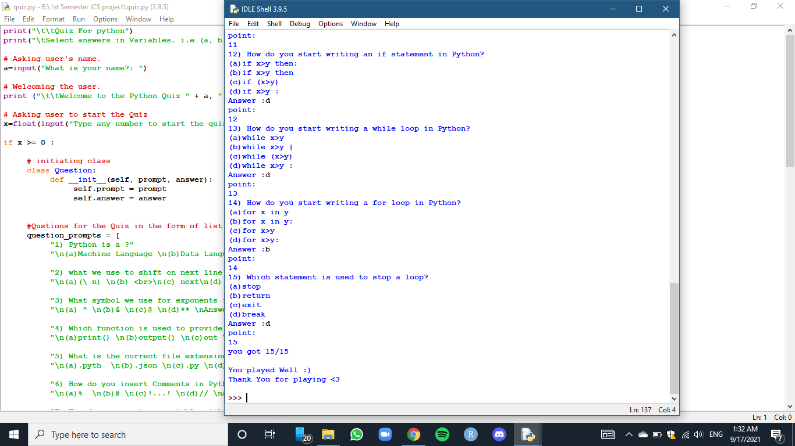

**CONCLUSION:**

It has been a great pleasure for me to work on this exciting and challenging project. This project proved good for me as it provided practical knowledge of programming in python. It also proves knowledge about the latest technology used in developing web enabled application and client server technology that will be great demand in future. This will provide better opportunities and guidance in future in developing projects independently.

**REFERENCE:**

I took a little bit of help in coding from YouTube and other programming sites.